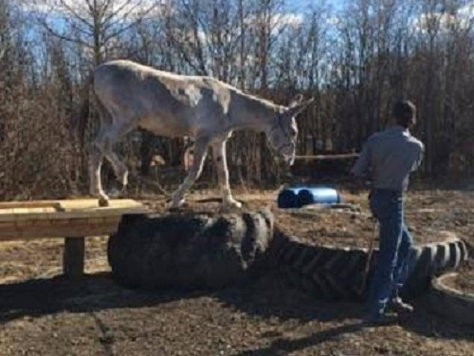
WHAT YOU CAN DO BEFORE HE’S TWO
by Betsy Hutchins
www.lovelongears.com
Every young equine should have learned a number of lessons before the age of two. One of the most pitiful sights I know is to see a group of unhanded two year olds go to the killer’s because people are afraid of trying to handle and train them. An unhanded two year old mule or horse is one of the most unsaleable animals known to man-and can be one of the most dangerous. Donkeys are not so bad, even an adult is easily trained, BUT PEOPLE ARE AFRAID TO TRY!
Anyone who takes on the responsibility of breeding young stock also takes on the responsibility of making that young stock gentle and trained enough to get a decent home for life. Anyone who buys a weanling or yearling should work with it to train it as much as possible before riding age, so that nobody gets hurt or scared or disappointed when the time come to ride or drive.
Here is a list of things you should do. (And some you can do if you want to)
Yearling to two year old
When your colt is a “teenager” it will have a bit longer attention span and can concentrate a little bit longer than when it was a yearling. Do keep the lessons SHORT and HAPPY!
1. By now your young equine should be able accept the halter, lead from either side, accept being handled all over from head to tail and you should be able to pick up all four feet. If not you must be sure they are all learned well before you go on to anything else.

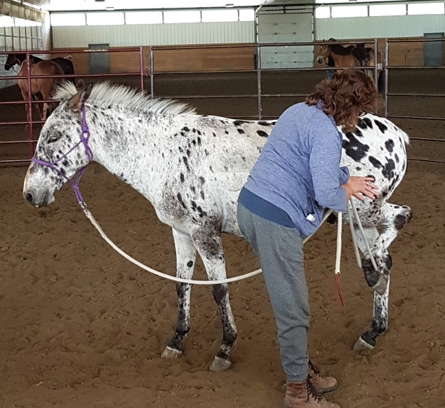
2. Teach your yearling to stand tied. This is crucial and will take time and tact with some animals.
3. Accustom your yearling to leading through gates, into odd places and through traffic and such things.
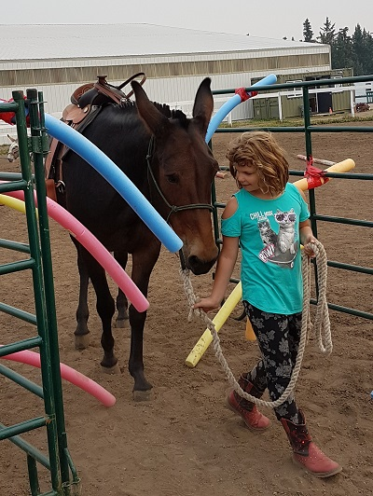
4. To get ready for the above, thoroughly get him used to being sacked out. Rub him all over with a cloth (use a cloth on the end of a fishing pole or bamboo or other stick if he is jumpy and dangerous to you). Then when he is calm after being rubbed flap it all over him until he practically falls asleep. TAKE YOUR TIME, DO NOT SCARE HIM- the idea is to teach him that this thing WILL NOT HURT HIM not to make him afraid of it!!!!! After he is used to the first cloth you can try other objects. One good one (but take it slow) is a plastic trash bag with some empty soft drink cans in it! – Do be careful though!
5. Teach you yearling to pivot on his front and then on his hind feet and at the same time to respond to pressure on his sides. I use the butt of my riding crop to provide the pressure for him to move away from. This comes in very handy when you finally get on and use leg pressure.
6. Teach you yearling to accept the feel of a saddle and girth. A training surcingle and even a child’s saddle pad with stirrups and girth come in handy for this. Again, take it slow, and do not scare him.
7. Teach the yearling to accept a bit. Use a snaffle [NO SHANKS] and just let him carry it some each day, drink and munch some hay to get used to it. Be sure it is adjusted carefully, one wrinkle at the side of the mouth is just right. Do not leave it on too long and get him disgusted at it.
8. Teach the yearling to drive in the long reins. Use the halter for control (do this in a fenced area). Later, just before he is broke to ride you can start long reining with the bit, but just now, let him carry the bit but snap the reins to the halter instead.
9. If you plan to show, practice for a few minutes a day the pose you wish your animal to assume in the ring. In most parts of the country this is the four square stance used by all the western horse breeds. Do not get discouraged – one day he will CATCH ON but it may take a while!
10. Once your yearling is leading really well teach him to trot next to you on the lead rope. This is always important. A good method is to stand at his shoulder, holding the lead in your right hand and a long whip in the left. Reach around back (looking innocently forward) and encourage him forward with the whip. It may take a helper the first few times.
11. Start teaching him to back up now. Most donkeys and many mules have a very rusty reverse gear, so teaching him to back first by halter and later in the long reins is very important to future training (and your future temper!)
12. Teach your foal and yearling to load and ride in the trailer now while the pressure is not on, you will be glad of this sooner than you think!
See what I mean - there are more things, limited only by the imagination, but since you only have two years here – this may be all you can get done. Just imaging the difference between this animal after the two year period since his birth, and the one that your irresponsible neighbor has left running with its dam for two years, or worse in a stall or small lot, with no training – which one is going to sell well, be a happy animal, have a good home and be a credit to its breed-!

