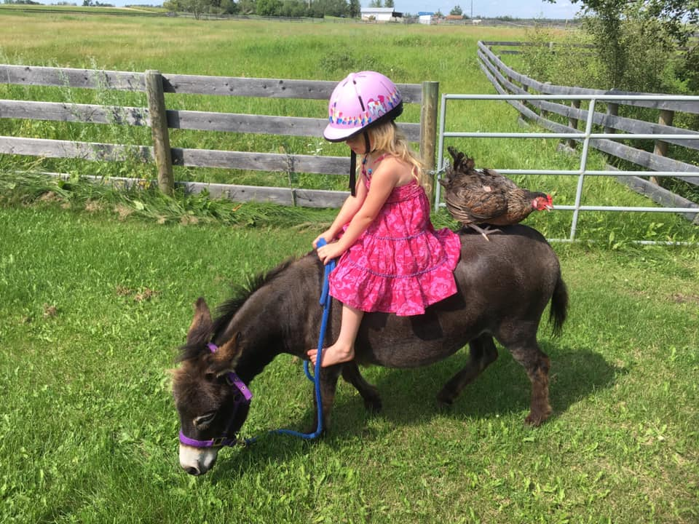
AN INTRODUCTION TO DONKEYS AS PETS
By Besty Hutchins
www.lovelongears.com
Although most equines, that is horses and ponies, are kept for their useful qualities and as pets only secondarily, the particular temperaments of the donkey makes him ideal for both a companion animal and for practical use for both adults and children.
The physical attributes of the donkey make him one of the best equines for people to keep under close circumstances. Donkeys have no body odor, even when sweating. They carefully deposit their manure in only one or two places, creating mounds, which are easy to clean away. They stay happily in a large back yard and do not contaminate the whole yard with droppings. (They DO eat roses however). They are usually small, and are docile to handle. They eat very little to stay fat, and require almost nothing in the way of equipment such as brushes and other grooming equipment and saddlery. The pet donkey is perfectly content with a halter, a rope, a currycomb to clean mud off with, a bridle and a bareback pad. If the animal is only to be petted or just led around with children aboard, a halter lead rope, and brush are all he will require as equipment. A hoof pick of some kind should be added to this list, to keep his feet clean.
The mentality of the donkey is what endears him to most people. A well-treated and properly raised donkey is extremely loving and loveable. We have always found that they are greatly different from horses and ponies in this respect. Most of them are content to rest their heads in their owner’s arms, laps or shoulders for hours while being petted. If a donkey has not been made fearful for its ears by harsh treatment, a favorite treat is to scratch the inside of the big ears and watch the expression of pure pleasure on the donkey’s face. Donkeys’ faces do have expression, if you have ever seen one laughing at you with his lip upraised you will know that! When the owner is working in the donkey’s enclosure, he will find that inquisitive head stuck right between him and his work, or looking over (and probably leaning on) his shoulder. Most pet donkeys don’t even think of flinching from such things as hammer blows, and can be quite a nuisance trying to get their nose under the hammer to examine the nail! One man of our acquaintance found the donkey’s habit of lying down and stretching out in the sun so charming that he bought one. He had always felt sorry for horses he said. They didn’t lie down very much and it made his feet hurt just to think of them standing all night! As you can see, this man did not pretend to be a horseman, and had no experience handling them, but he and his pet donkey became very close, and the donkey furthered his equine education. He still thinks donkeys are more sensible because they lie down and rest their feet!
The donkey shows his difference from the horse and pony in many other ways than conformation and long ears and voice. People acquainted with horses find endless fascination in watching the little differences between the species. For instance, you must never water a hot horse or he will drink too much and founder. Did you know that the Desert Research Institute in Nevada proved that the donkey does not drink too much because of its desert heritage? Donkeys and camels both have an internal mechanism, which regulates water intake! Neither animal will drink more than exactly the amount his body tissue lack. When he has drunk ONLY the amount of water he needs, the donkey will quit!
Donkeys often prefer human companionship to that of other animals. Geldings and Jennies especially can live quite happily with plenty of human attention without yearning for their own kind. As a matter of fact, a real pet will often sulk and be “jealous” of a new donkey added to their “kingdom” until they get used to it. Even after that the two will compete with each other for petting and human attention. Perhaps this quality of difference from other equine, and the fact that donkeys are interested in, and loving toward humans, as well as being willing to show their affection physically is the most endearing quality about the pet donkey.
The gestation period of the donkey is 12 months, instead of the 11 for a horse. They say that God gave the donkey an extra month to put on all his intelligence! The burro, ass and donkey are all different words for the same animal. Burro is simply the Spanish word for a small ass; donkey is the English word. Donkey is derived from dun-key, in middle English, which means a small, dun colored animal. Ass is the proper name for all breeds and typed of donkeys. The scientific name is equus asinus, whence the proper name, ass. If you live in our Western states, under the Spanish influence you will probably call your pet a burro, if you live in the East, he will be a donkey to you. In both places it will be a constant irritation to you to find that people insist on calling him a mule. By the way, a mule is a hybrid, the cross of a male donkey with a female horse. The hinny is the result of a cross between a male horse and a female donkey, and is basically just the same as a mule. These animals combine the size and spirit of the horse, with the stamina, ears, and intelligence of the donkey, and are excellent animals for the more experienced horseman.
There is some confusion over the “breeds” and types of ass in the United States. The most common and lest expensive donkey found is our “Native American ass”. This animal whom the Spanish called a burro, was introduced first by Spanish explorers, and many have come in later times from Mexico. It can be of many colors, including spotted (pinto) and is of many varying strains of bloodlines and types of conformation. The height variations are extreme, varying from about 39 inches to 58 inches at the withers. It is the most varied of our donkeys and can be chosen for any occupation from a first ride for a small child, to driving in a show ring, to carrying a heavy pack in the mountains. Wild burros can even be adopted free from the Bureau of Land Management, and when tamed, make excellent pets. Temperament does not vary with breed to any great extent in the ass, although the very largest breeds have a tendency to be sluggish due to their larger size. A well-treated animal is usually a fine pet, no matter what breed or type it is. This quality makes it easy to select the animal you wish, from any of the types and sizes available.
The two breeds of donkey in the United States that are “purebred” are the Sicilian and Sardinian Miniature donkey, and the American Standard “Mammoth” jackstock. The miniatures were originally imported from Sicily and Sardinia. They are from 30 to 36 inches tall at the withers, and of stocky strong conformation and good disposition. They are usually grey or dark brown.
These small donkeys are good for pets, for small children to ride, for driving and for show. Geldings are less expensive than breeding stock, and make better pets.
The “Mammoth” jack and jennet are very large indeed and rarely kept as pets. They stand from 56” at the lower limits of the breed, to 16 hands high, as large as a large horse. They have heavy bone and are used to breed large mules. They are expensive and rather rare and are extremely impressive animals! They can be ridden or driven and have the same temperament as the smaller animals, but may be more sluggish if they are very large.
The America Donkey and Mule Society has full literature and a list of available books on these animals. A breeders listing is also available from this office. If the breeders listing shows no breeders near you, an ad in the local paper, or in your local or state horse publications will almost certainly turn up some donkeys. Try to be particular with what you buy, and look for good temperament and good health and an appearance that is pleasing to you as an individual
.
No matter what size your long-eared pet is, his physical care is quite simple and basic. In cold or changeable weather a good shelter is necessary. Donkeys are desert animals and need shelter to protect them from cold winds and from cold rain and snow. Jennets in foal and foals are susceptible to respiratory disease. All donkeys are rather susceptible to pneumonia, so that if your pet ever appears to have a cold, call the vet immediately.
This is not common- but can happen in really bad weather. Donkeys grow extremely thick, long and dense hair in the winter months and keep it well into fly season, thus protecting themselves against colds and flies with one coat. If your animal is out in the winter do not brush his coat clean- the donkey loves to roll in dust and mud. You can brush the outer mud off, but leave what is in the coat-it provides natures insulation.
You will notice that a donkey never shakes anything but his head when he gets up from rolling, unlike a horse, which shakes all over. This is another symptom of his desert heritage. Like the nomad who washes his hand in desert sand to conserve water, the donkey washes in dust. It also stays in that thick coat to protect him from the sun, wind, or cold. In summer, when all cold is gone, donkeys that can be sprayed for flies may be clipped completely over the body with horse clippers. In more moderate climates a shelter with one closed side, towards the prevailing winter wind is quite useful.
The best food for a donkey that is not working hard is grass. If grass is sparse or unavailable, then good quality hay should be provided. This is sometimes supplemented with a mixed type horse feed if the donkey falls off in condition. A supplementary feed is also needed for jennies in foal or nursing foals and for the weaned foals also. Common sense and observation should tell the owner if his donkey is losing weight. If the coat is long it should be carefully felt to see that the ribs are not showing under a blanket of “fat looking” hair.
It is a common tendency of donkeys to become over fat just as with ponies and this should be guarded against. Donkeys are very particular about their water and should have fresh water every day. They will go without water even in summer weather, if it is stale, and will immediately drink their fill when the water is changed. Donkeys will create their own “rolling place” as soon as they are put in an enclosure to live. If the rolling place has little sand, a load of clean sand will be appreciated greatly by the donkey.
Donkeys take easily to picket rope and stake also. If you do not have fresh grass you can stake with about 30 feet of soft rope. Keep an eye on the animal, donkeys are good with rope, but accidents can happen. Do not leave for more than a few hours at a time on the stake rope. Just long enough to get a tummy full of fresh grass. NEVER LEAVE A DONKEY OR PONY STAKED PERMANENTLY, THIS IS CRUEL.
The other thing about physical care which must be emphasized is proper worming and care of the feet. Donkeys should be wormed with any good commercial preparation in spring and fall. If the local horsemen consider any immunizations especially necessary your vet can give them to your donkey also. A farrier should keep the animal’s feet trimmed, as they will grow so long as to cripple the animal otherwise. Even if a donkey is purchased with long hoofs a good farrier, by a series of trimmings can usually bring the feet back to good order. A trimming once every two or three months is usually enough, but neglect of the feet is the most common and serious error that donkey owners can make. A farrier can almost always be found through a local vet, stable, or horse breeder. Donkeys are almost never shod, but then can be if necessary with cut down pony shoes.
Buying a young, untrained animal is the best way to get a pet that is your own creation. You shouldn’t find training to be any problem. Once you have the confidence and love of the animal. A firm “NO” and a jerk on the halter will usually be enough to keep your pet on the straight and narrow. Contrary to popular myth, donkeys are not stubborn. What is often perceived, as stubbornness is either fear or lack of training. Space does not permit detailed descriptions of training but there are a good many books on the subject that are readily available.

